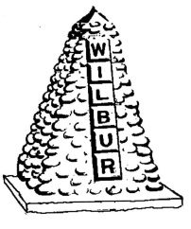

PUBLIC NOTICE

THE TOWN OF WILBUR
REGULAR COUNCIL MEETING

APRIL 3, 2019 AT 6:00 PM
ONE TIME, TIME CHANGE

WILBUR TOWN HALL
14 N.W. DIVISION STREET
WILBUR, WA

