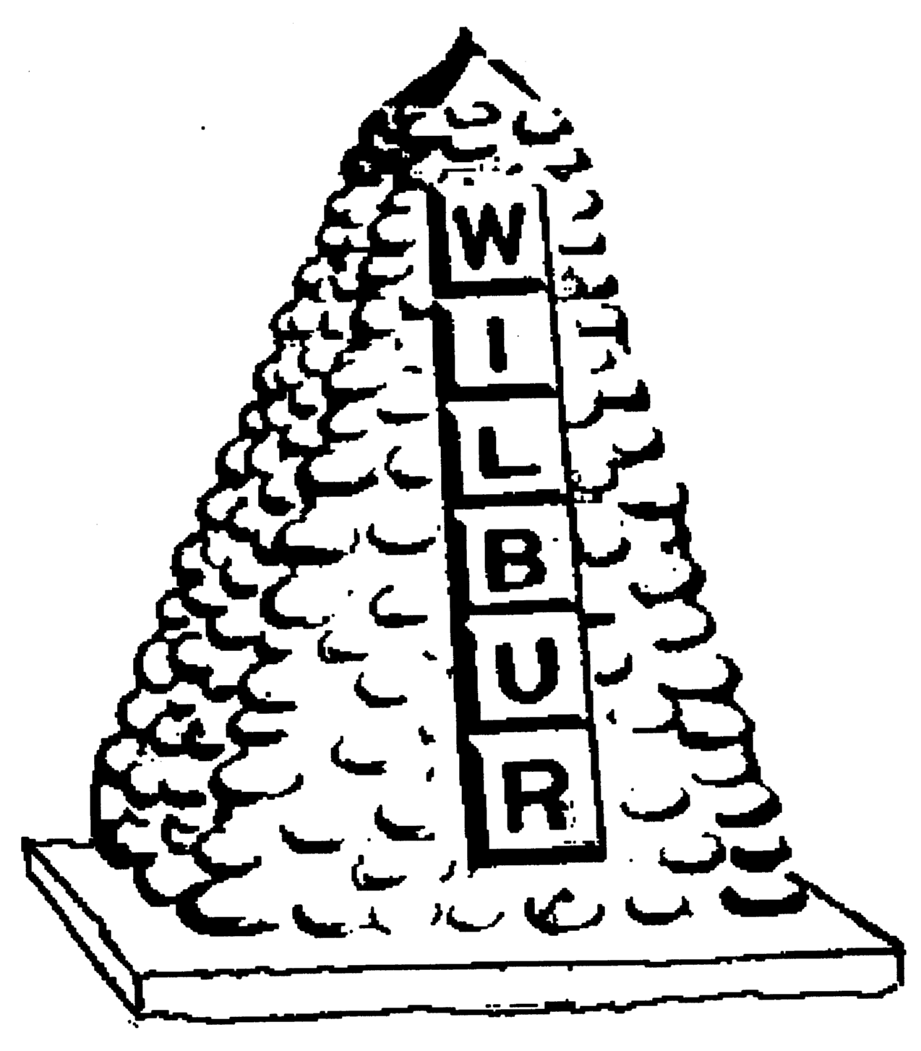
TOWN OF WILBUR COUNCIL
MAYOR GLORIA KUCHENBUCH
KENT ANDERSEN, ERICA HEARREAN, ROY SCHEIBNER, DAVID WELLS, JOHN HANON

-AGENDA-
January 2, 2020 7pm, Regular Meeting
Town Hall, Wilbur, WA

HEARING IMPAIRED (VOICE) 1-800-833-6384 (TDD/TTY) 1-800-833-638
REGULAR HEARING
- Pledge of Allegiance
- Oath of Office – All members
- Additions or corrections to agenda

CONSENT AGENDA
- Approval of:
- Payroll warrant #’s 23199-23220 in the amount of $17,931.86 dated December 30, 2019.
- Accounts Payable warrant #’s 23221-23234 in the amount of $83,903.99 dated December 31, 2019.
- Approval of minutes from December 18, 2019 for regular council session.

REGULAR/NEW SESSION
1. Citizen comments - State your name & limit your comments to 3 minutes,
2. Flood Mitigation
3. Executive Session announced for December 18, 2019. 7:30pm – 8:50pm. City Attorney David Bingaman was present via speakerphone conference call.
4. Hawley Probate
5. City Engineer
6. City Council Position #2

RESOLUTION/ORDINANCE
None
DONATIONS
$2,000 – Wilbur Museum
$250 – Fire Dept.
MAYOR, STAFF & COMMITTEE REPORTS
- Mayor’s Report
- Council Members Report
- Clerk/Treasurer’s Report
- Fire/EMS Chief Report
- Library

Mission Statement
To provide the citizens of the Town of Wilbur with the best and most efficient services possible that protect and enhance the quality of life through planning, visionary leadership and dedicated employees. Realizing that the strength of our mission lies in our commitment to the following values, we believe in:
PRIDE in our work, in our dedication to public service, and in being the best we can be.
HONESTY in all our actions with employees and citizens.
PARTICIPATION by citizens and Town team members in setting and attaining the Town's goals.
INNOVATION in meeting the present and future needs of the Town.
LOYALTY to our community, to this organization, and to each team member.
RESPECT for, and belief in, individual differences and the worth of every person.

