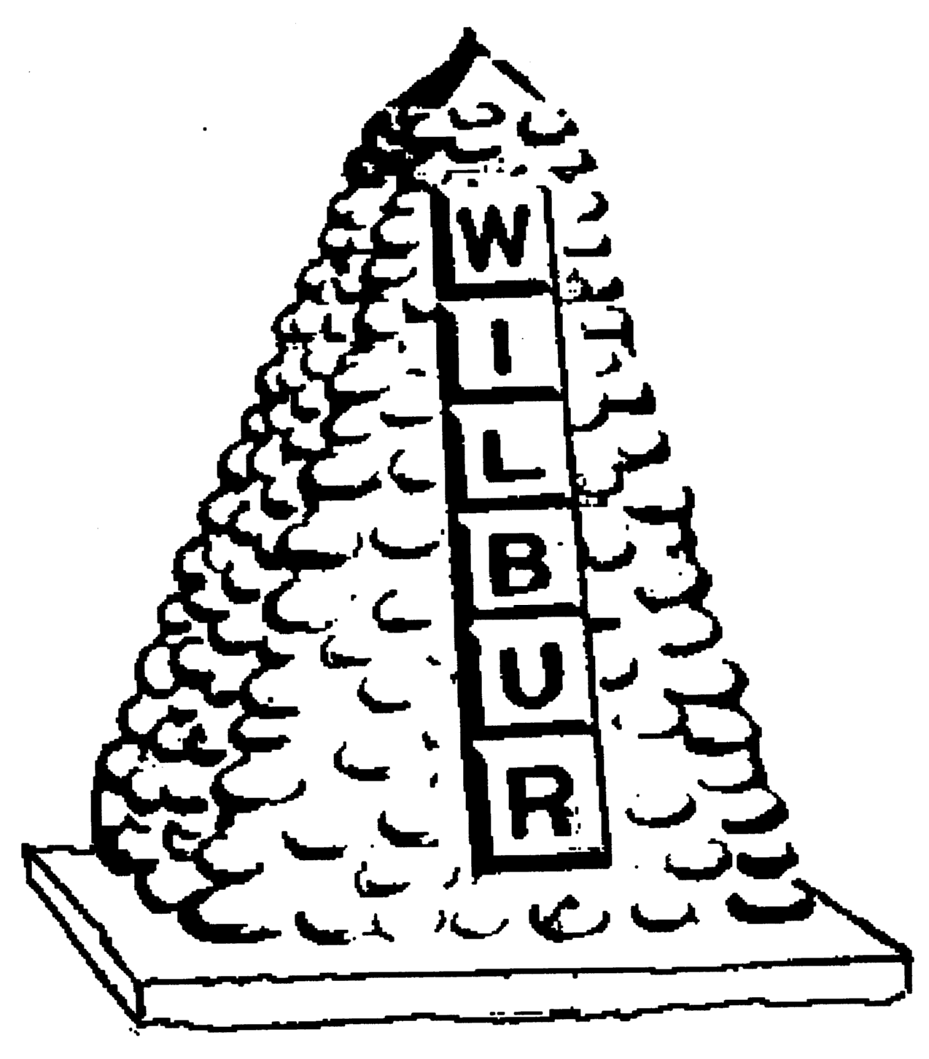
TOWN OF WILBUR COUNCIL
MAYOR ERICA HEARREAN
MAYOR PRO TEM KENT ANDERSEN, ROY SCHEIBNER, JOHN HANON, NICHOLE CURTIS

-AGENDA-
February 19, 2020 7pm, Regular Meeting
Town Hall, Wilbur, WA

HEARING IMPAIRED (VOICE) 1-800-833-6384 (TDD/TTY) 1-800-833-638
REGULAR HEARING
- Pledge of Allegiance
- Roll Call
- Additions or corrections to agenda

CONSENT AGENDA
Approval of:
- Payroll warrant #’s 23316-23317 in the amount of $2,000.00 dated February 14, 2020.
- Accounts Payable warrant #’s ? in the amount of $ ? dated February 19, 2020.
- Approval of minutes from January 15, 2020 for regular council session.

REGULAR/NEW SESSION
- Citizen comments - State your name & limit your comments to 3 minutes,
- Wilbur Chamber of Commerce – Courtney Ruiz
- Town Engineer-Vote
- Airport Engineer – Steve Nelson (Century West)
- Lincoln County Sherriff – Wade Magers
- Online bill pay/credit card payments-Vote on Armada

RESOLUTION/ORDINANCE
Ordinance #585 – amending original ordinance pertaining to the location of the Town Council Meetings.
DONATIONS
None
MAYOR, STAFF & COMMITTEE REPORTS
- Mayor’s Report
- Council Members Report
- Fire/EMS Chief Report
- Library

Mission Statement
To provide the citizens of the Town of Wilbur with the best and most efficient services possible that protect and enhance the quality of life through planning, visionary leadership and dedicated employees. Realizing that the strength of our mission lies in our commitment to the following values, we believe in:
PRIDE in our work, in our dedication to public service, and in being the best we can be.
HONESTY in all our actions with employees and citizens.
PARTICIPATION by citizens and Town team members in setting and attaining the Town's goals.
INNOVATION in meeting the present and future needs of the Town.
LOYALTY to our community, to this organization, and to each team member.
RESPECT for, and belief in, individual differences and the worth of every person.

