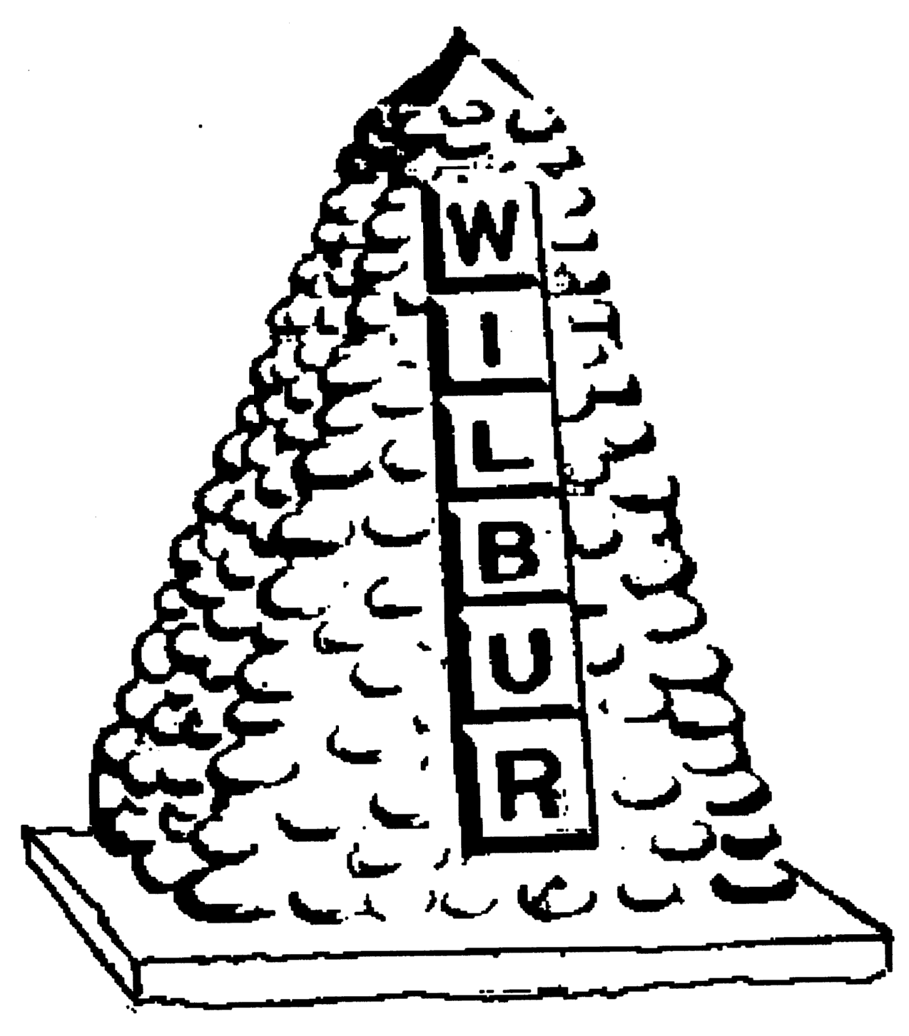
TOWN OF WILBUR COUNCIL
MAYOR ERICA HEARREAN
MAYOR PRO TEM KENT ANDERSEN, ROY SCHEIBNER, JOHN HANON, NICHOLE CURTIS

-AGENDA-
February 5, 2020 7pm, Regular Meeting
Wilbur Senior Center, Wilbur, WA

HEARING IMPAIRED (VOICE) 1-800-833-6384 (TDD/TTY) 1-800-833-638
REGULAR HEARING
- Pledge of Allegiance
- Roll Call
- Additions or corrections to agenda

CONSENT AGENDA
Approval of:
- Payroll warrant #’s 23284-23298 & 2 EFT’s in the amount of $25,057.51 dated January 30, 2020.
- Accounts Payable warrant #’s 23263-23271 in the amount of $14,462.37 dated February 5, 2020. (Year End)
- Accounts Payable warrant #’s 23281-23283 in the amount of $ dated February 5, 2020.
- Voided check #’s 23272-23280 due to misprint.
- Approval of minutes from January 15, 2020 for regular council session.

REGULAR/NEW SESSION
- Citizen comments - State your name & limit your comments to 3 minutes,
- Executive Session – Previous to regular council meeting, times, lawyer present, reason.
- Town Council Position #2
- Swimming Pool Manager position
- Airport Engineer – Robert Wyborney
- Airport Board
- IT for Town
- Hearing Examiner – Fee goes to permit holder
- Changes to personnel policy-probation period
- Town Engineer update
- Public Records Act Training- Every 4 years
- Open Public Meeting Training- Every 4 years
- Online bill pay/credit card payments

RESOLUTION/ORDINANCE
Resolution #486 – Amendment to the 2019 Budget for fund shortage.
DONATIONS
$50 – Big Bend Historical Society
MAYOR, STAFF & COMMITTEE REPORTS
- Mayor’s Report
- Council Members Report
- Clerk/Treasurer’s Report - Training
- Fire/EMS Chief Report
- Library

Mission Statement
To provide the citizens of the Town of Wilbur with the best and most efficient services possible that protect and enhance the quality of life through planning, visionary leadership and dedicated employees. Realizing that the strength of our mission lies in our commitment to the following values, we believe in:
PRIDE in our work, in our dedication to public service, and in being the best we can be.
HONESTY in all our actions with employees and citizens.
PARTICIPATION by citizens and Town team members in setting and attaining the Town's goals.
INNOVATION in meeting the present and future needs of the Town.
LOYALTY to our community, to this organization, and to each team member.
RESPECT for, and belief in, individual differences and the worth of every person.

