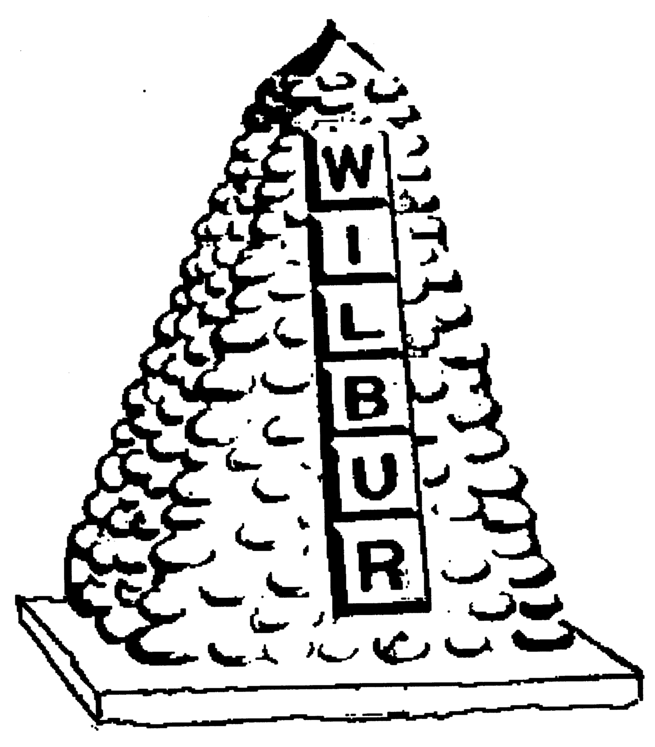
TOWN OF WILBUR COUNCIL
MAYOR ERICA HEARREAN
MAYOR PRO TEM KENT ANDERSEN, ROY SCHEIBNER, JOHN HANON, NICHOLE CURTIS

-AGENDA-
March 18, 2020 7pm, Regular Meeting, Town Hall, Wilbur, WA

HEARING IMPAIRED (VOICE) 1-800-833-6384 (TDD/TTY) 1-800-833-638
REGULAR HEARING
- Pledge of Allegiance
- Roll Call
- Additions or corrections to agenda

CONSENT AGENDA
Approval of:
- Payroll warrant #’s 23366-23367 in the amount of $2,000.00 dated March 13, 2020.
- Accounts Payable warrant #’s 23365, 23368- in the amount of $ ? dated March 18, 2020.
- Approval of minutes from March 4, 2020 for regular council session.

REGULAR/NEW SESSION
Citizen comments - State your name & limit your comments to 3 minutes
PREVIOUS TOPICS
- Wilbur Engineer project status update – questions?
- Goose Creek analysis – questions?
- ORV Park Board - update
- Social Security Breach - update
- Year End update – Melissa Bulger
- Visitor’s Guide Ad – Frank Steadman
- Claims & lawsuit against town – update
NEW TOPICS
- Airport project approval – matching funds
- Alibi Liquor license renewal
- Free brush pile weekends
- Corona Virus discussion

RESOLUTION/ORDINANCE
Resolution #487 - Airport grant match funds
Ordinance #586 - 2019 year end funds fix
Ordinance #587 – Amendment to Wilbur Fire Dept/EMS Policy
DONATIONS
$25 – Wilbur Fire Dept
MAYOR, STAFF & COMMITTEE REPORTS
- Mayor’s Report – 514 Cole cleanup, future meetings-emergency authority
- Council Members Report
- Fire/EMS Chief Report
- Library/Public Works/Treasurer

Mission Statement
To provide the citizens of the Town of Wilbur with the best and most efficient services possible that protect and enhance the quality of life through planning, visionary leadership and dedicated employees. Realizing that the strength of our mission lies in our commitment to the following values, we believe in:
PRIDE in our work, in our dedication to public service, and in being the best we can be.
HONESTY in all our actions with employees and citizens.
PARTICIPATION by citizens and Town team members in setting and attaining the Town's goals.
INNOVATION in meeting the present and future needs of the Town.
LOYALTY to our community, to this organization, and to each team member.
RESPECT for, and belief in, individual differences and the worth of every person.

