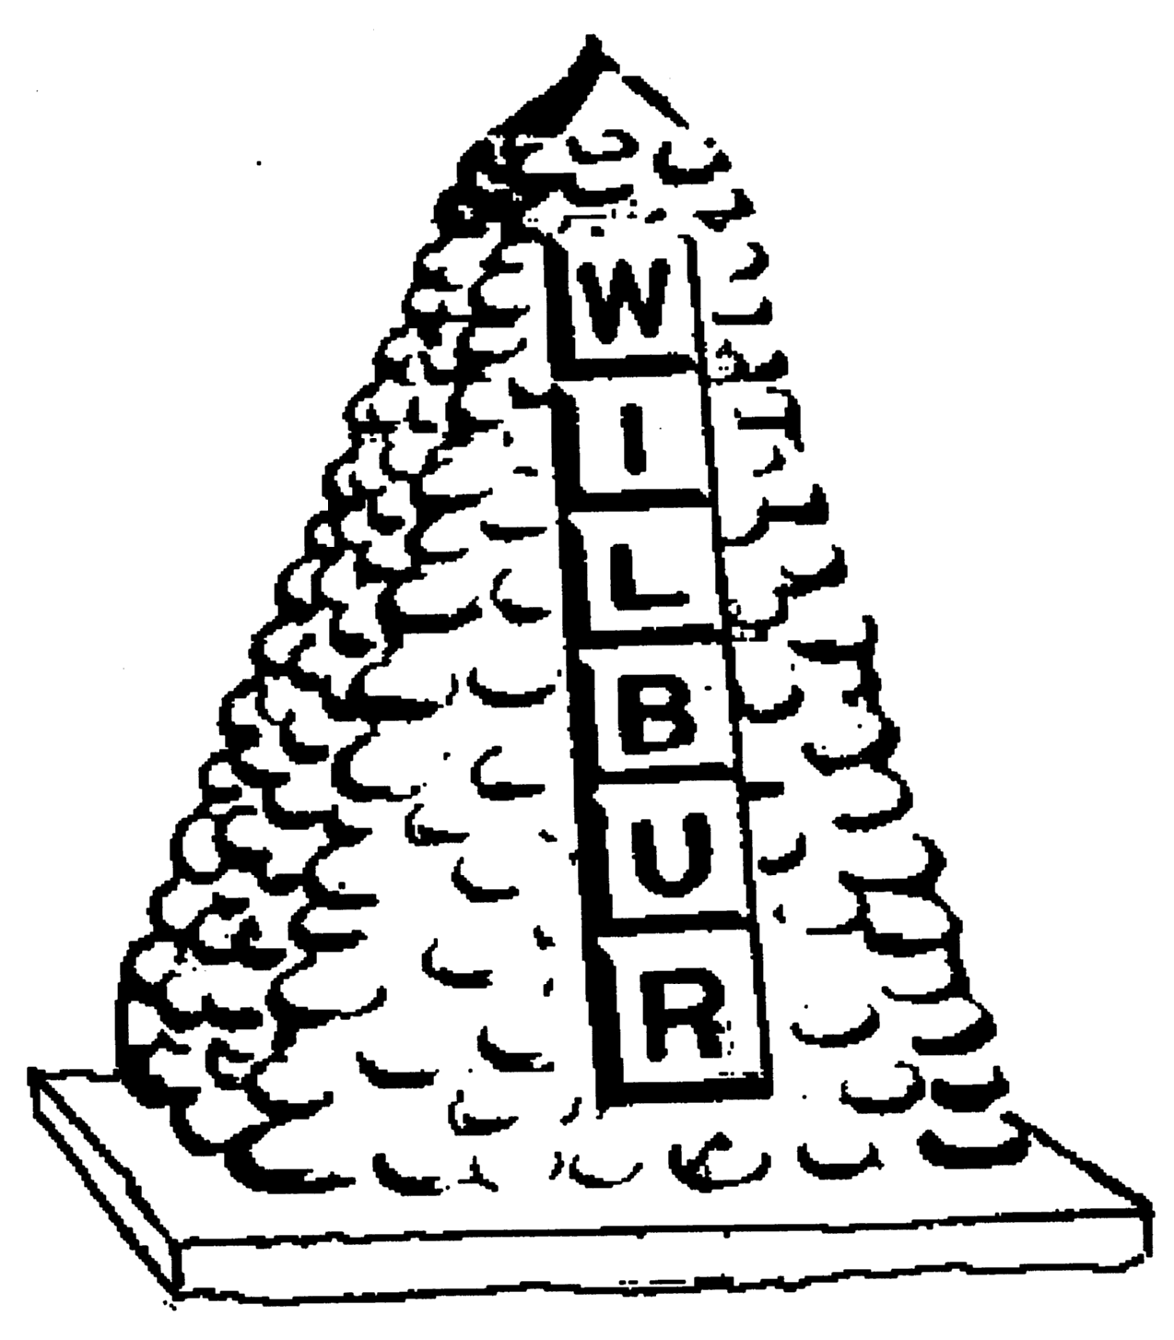
TOWN OF WILBUR COUNCIL
MAYOR ERICA HEARREAN
MAYOR PRO TEM KENT ANDERSEN, ROY SCHEIBNER, JOHN HANON,
NICHOLE CURTIS & LYNN MCWHORTER

-AGENDA-
May 20, 2020 7pm, Regular Meeting, Town Hall, Wilbur, WA
HEARING IMPAIRED (VOICE) 1-800-833-6384 (TDD/TTY) 1-800-833-6384
Zoom Meeting https://zoom.us/j/96115512794 phone 1-800-944-8766, participant code 80433#
REGULAR HEARING
- Pledge of Allegiance
- Roll Call
- Additions or corrections to agenda –

CONSENT AGENDA
Approval of:
- Payroll warrant #’s 23385-23414 in the amount of $32,570.43 dated March 24, 2020.
- Payroll warrant #’s 23452-23453 in the amount of $2,000.00 dated April 15, 2020.
- Payroll warrant #’s 23454-23470 in the amount of $28,806.25 dated April 30, 2020.
- Payroll warrant #’s 23490-23491 in the amount of $2,000.00 dated May 15, 2020.
- Accounts Payable warrant #’s 23415-23428 in the amount of $18,000.05 dated April 1, 2020.
- Accounts Payable warrant #’s 23429-23451 in the amount of $20,889.89 dated April 15, 2020.
- Accounts Payable warrant #’s 23471-23489 in the amount of $198,705.40 dated May 6, 2020.
- Accounts Payable warrant #’s 23492- ? in the amount of $ ?? dated May 20, 2020.
- Approval of minutes from March 18, 2020 for regular council session.

REGULAR/NEW SESSION
Citizen comments – Removed due to Governor Inslee’s Co-vid 19 Proclamation.
NEW TOPICS
Town events – Cancelled/Rescheduled due to Co-vid 19.

RESOLUTION/ORDINANCE
Resolution #490 – Greenhouse Gas’s Policy
Resolution #491 – Asset Management Plan with Certification of Compliance
Resolution #492 - 2020 Water Main/Streets CDBG with Certification of Compliance
Resolution #493 - Grievance Procedure for the Use of CDBG Funds
DONATIONS
None
MAYOR, STAFF & COMMITTEE REPORTS – Only co-vid 19 related topics.
- Mayor’s Report
- Council Members Report
- Fire/EMS Chief Report
- Library/Public Works/Treasurer

Mission Statement
To provide the citizens of the Town of Wilbur with the best and most efficient services possible that protect and enhance the quality of life through planning, visionary leadership and dedicated employees. Realizing that the strength of our mission lies in our commitment to the following values, we believe in:
PRIDE in our work, in our dedication to public service, and in being the best we can be.
HONESTY in all our actions with employees and citizens.
PARTICIPATION by citizens and Town team members in setting and attaining the Town's goals.
INNOVATION in meeting the present and future needs of the Town.
LOYALTY to our community, to this organization, and to each team member.
RESPECT for, and belief in, individual differences and the worth of every person.

