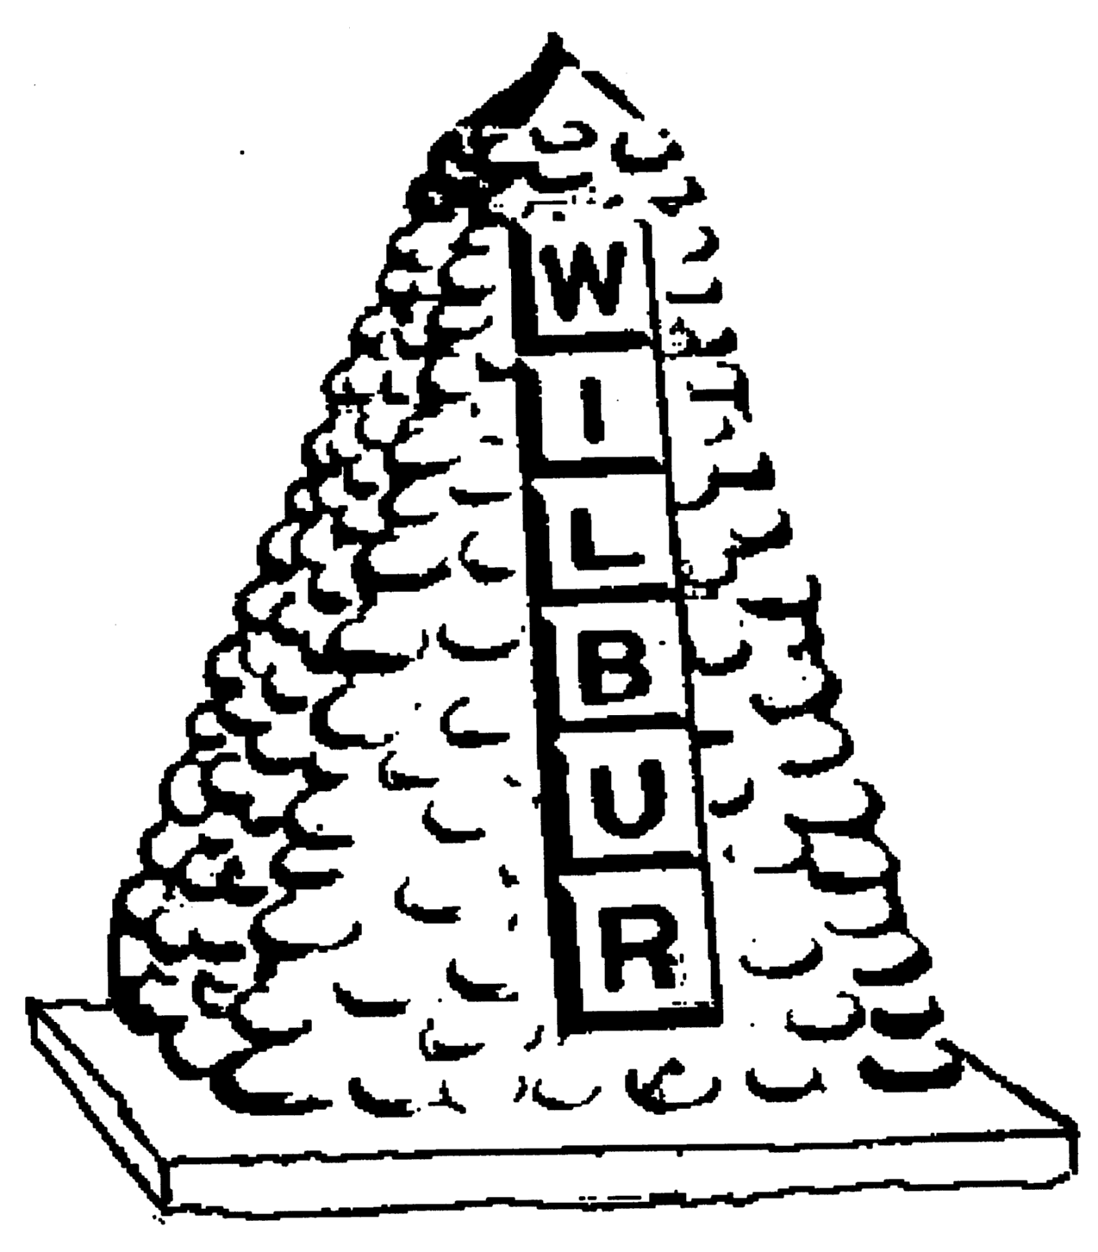
TOWN OF WILBUR COUNCIL
MAYOR ERICA HEARREAN
MAYOR PRO TEM KENT ANDERSEN, ROY SCHEIBNER, JOHN HANON,
NICHOLE CURTIS & LYNN MCWHORTER

-AGENDA-
July 21, 2020 7pm, Regular Meeting, Town Hall, Wilbur, WA
HEARING IMPAIRED (VOICE) 1-800-833-6384 (TDD/TTY) 1-800-833-6384
Zoom Meeting: https://zoom.us/j/95432191092 or by phone 1-844-855-4444, participant code 1130603

REGULAR HEARING
- Pledge of Allegiance
- Roll Call
- Additions or corrections to agenda –
CONSENT AGENDA
Approval of:
- Payroll warrant’s #23633-23634 in the amount of $2,000.00 dated July 15, 2020.
- Accounts Payable warrant #’s ? in the amount of $ ? dated July 21, 2020.
- Approval of minutes from July 7, 2020 for regular council session.

REGULAR/NEW SESSION
Citizen comments – Removed due to Governor Inslee’s Co-vid 19 Proclamation.
NEW TOPICS
- Mayor Pro-tem vote.
- Nuisance Director – list of issues handed in to Town Hall office.
- Critical Areas Ordinance - Melissa
OLD TOPICS
- Proposals for ORV Park Lease - Update
- Budget meetings: Budget 101 class reminder 7/22 9am.
- Bias Software zoom meeting- reminder 7/22 10am.
- Utility Assistance Application-Update

RESOLUTION/ORDINANCE
Ordinance #588 – Amendment to Ordinance #587 regarding Town Council Meeting location.
DONATIONS
Wilbur Cemetery- In memory of Elver R Buckley & Mary Irene Buckley - $500
MAYOR, STAFF & COMMITTEE REPORTS
- Mayor’s Report
- Council Members Report
- Fire/EMS Chief Report
- Library/Public Works/Treasurer

Mission Statement
To provide the citizens of the Town of Wilbur with the best and most efficient services possible that protect and enhance the quality of life through planning, visionary leadership and dedicated employees. Realizing that the strength of our mission lies in our commitment to the following values, we believe in:
PRIDE in our work, in our dedication to public service, and in being the best we can be.
HONESTY in all our actions with employees and citizens.
PARTICIPATION by citizens and Town team members in setting and attaining the Town's goals.
INNOVATION in meeting the present and future needs of the Town.
LOYALTY to our community, to this organization, and to each team member.
RESPECT for, and belief in, individual differences and the worth of every person.

