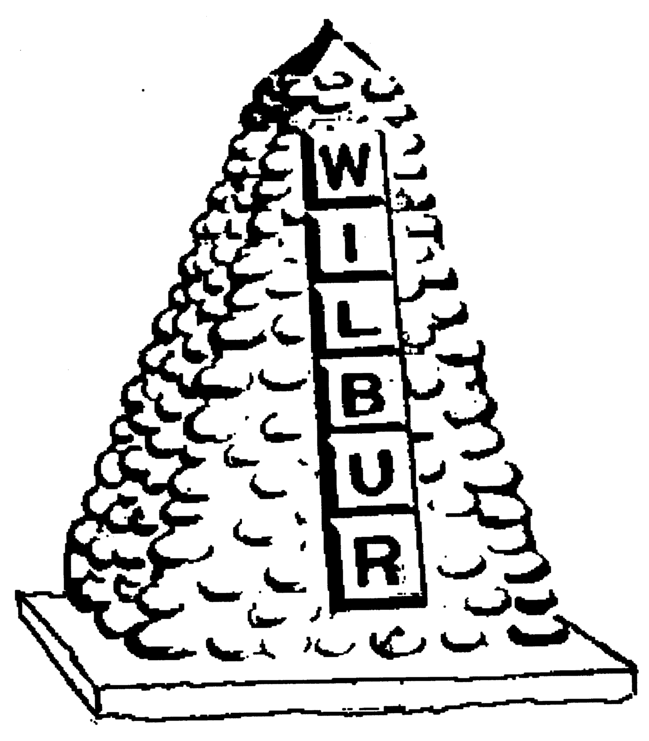
TOWN OF WILBUR COUNCIL
MAYOR ERICA HEARREAN
MAYOR PRO TEM KENT ANDERSEN, ROY SCHEIBNER, JOHN HANON,
NICHOLE CURTIS & LYNN MCWHORTER

-AGENDA-
July 7, 2020 7pm, Regular Meeting, Town Hall, Wilbur, WA
HEARING IMPAIRED (VOICE) 1-800-833-6384 (TDD/TTY) 1-800-833-6384
Zoom Meeting: https://zoom.us/j/92868473113 or by phone 1-844-855-4444, participant code 1130603

REGULAR HEARING
- Pledge of Allegiance
- Roll Call
- Additions or corrections to agenda – Wilbur Fire Dept., New Copier, Approval of Special Meeting Minutes from June 22, 2020, Lincoln Co. Sheriff’s Office June Report & Resolution #495**
CONSENT AGENDA
Approval of:
- Payroll warrant’s #23566-23606 in the amount of $39,192.09 dated June 15, 2020.
- Voided Payroll warrant’s # 23582 & 23604 in the amount of $506.22 dated June 30, 2020.
- Accounts Payable warrant #’s 23607-23632 in the amount of $33,130.68 dated July 7, 2020.
- Approval of minutes from June 17, 2020 for regular council session and Special Meeting minutes from June 22, 2020**

REGULAR/NEW SESSION
Citizen comments – Removed due to Governor Inslee’s Co-vid 19 Proclamation.
NEW TOPICS
- Andy Clark – ORV Park Board
- Accepting proposals for ORV Park Lease
- Utility Assistance Application (specifics) Innovia Grant
- Bias Software zoom meeting-Wednesday July 22nd.
- Nuisance Director – list of issues handed in to Town Hall office.
- EDC update – Grant’s available
- Wilbur Fire Department**
- Lincoln County Sheriff’s Office June Report**
OLD TOPICS
- List of surplus items - pricing
- Budget meetings: Budget 101 class date set (July 22nd)

RESOLUTION/ORDINANCE
Resolution #495 – Adoption of an Interlocal Agreement for Fire Protection with Lincoln Co. Fire District #7**
DONATIONS
Wilbur Pool- In memory of Sherri Jording- $30.00
MAYOR, STAFF & COMMITTEE REPORTS
- Mayor’s Report
- Council Members Report
- Fire/EMS Chief Report
- Library/Public Works/Treasurer – New Copier**

Mission Statement
To provide the citizens of the Town of Wilbur with the best and most efficient services possible that protect and enhance the quality of life through planning, visionary leadership and dedicated employees. Realizing that the strength of our mission lies in our commitment to the following values, we believe in:
PRIDE in our work, in our dedication to public service, and in being the best we can be.
HONESTY in all our actions with employees and citizens.
PARTICIPATION by citizens and Town team members in setting and attaining the Town's goals.
INNOVATION in meeting the present and future needs of the Town.
LOYALTY to our community, to this organization, and to each team member.
RESPECT for, and belief in, individual differences and the worth of every person.

